

Subject:- Machine Learning

**Weekly Report Submission 2**

GROUP: **DATA DYNAMOS**

Submitted to faculty: Prof. Mehul Raval

Date of Submission: 25/02/2023

**Student Details**

| Roll No. | Name of the Student | Name of the Program |
| --- | --- | --- |
| AU2040122 | Aditi Vasa | Btech CSE |
| AU2040002 | Shrey Somani | Btech CSE |
| AU2040196 | Vandan Shah | Btech CSE |
| AU2040048 | Ronit Shah | Btech CSE |

(Winter Semester)

**Report**

**Started with encoding of nominal data for the second week**

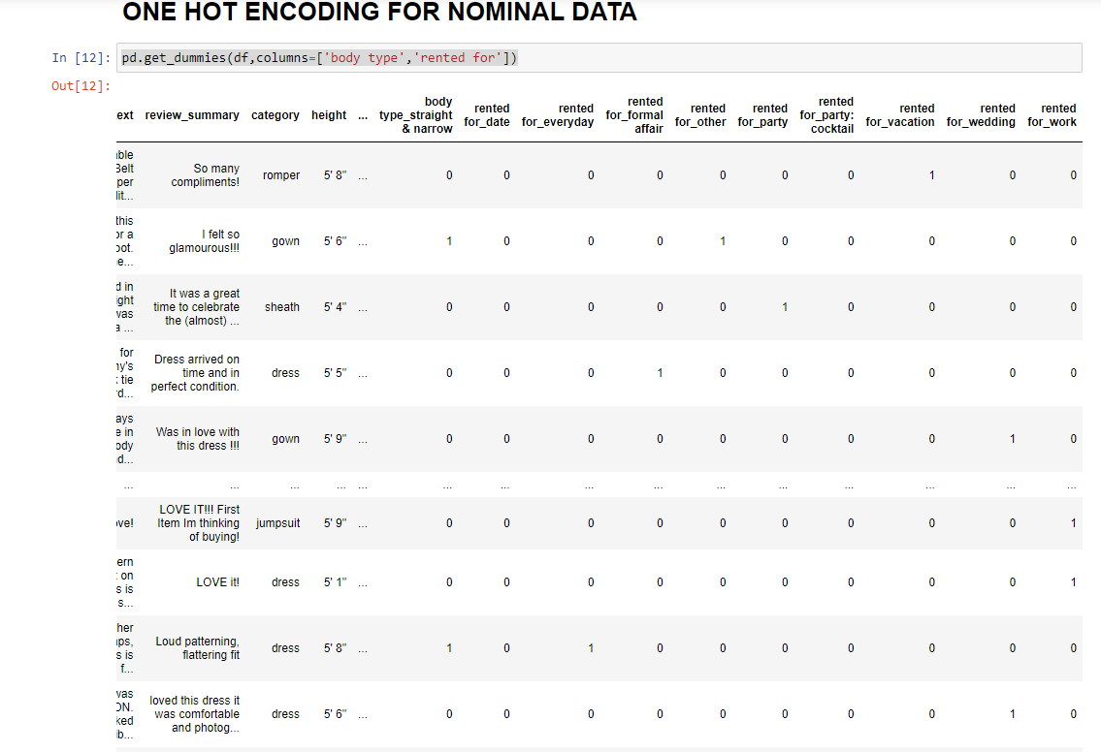

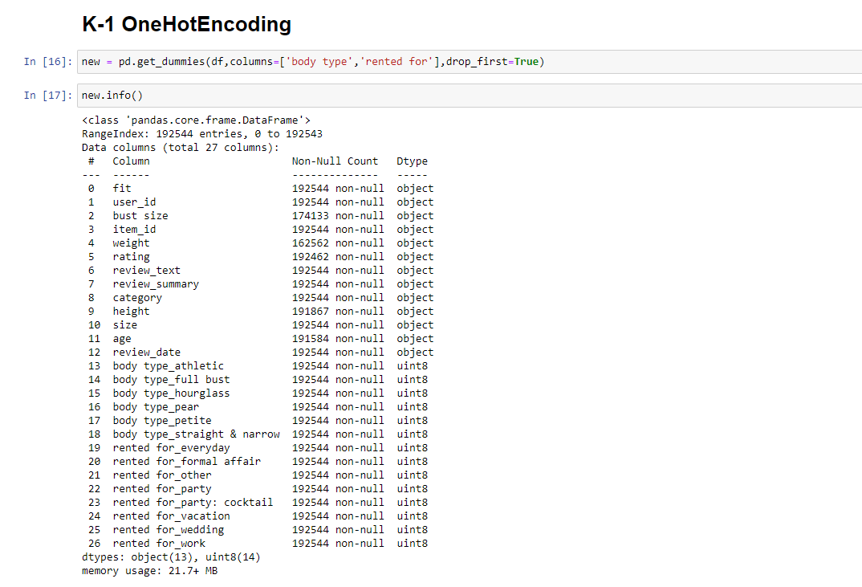

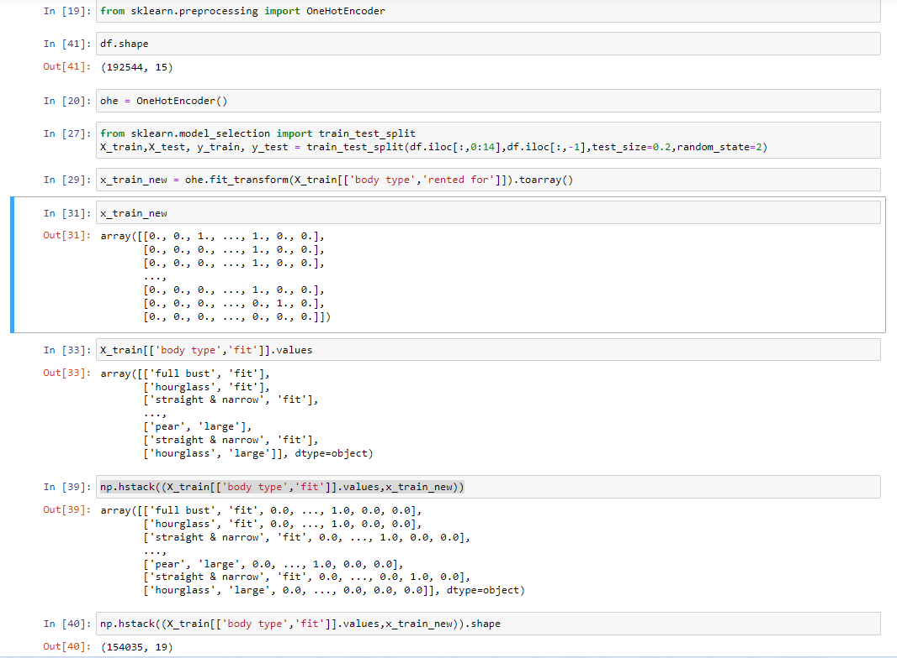

We have tried doing OneHotEncoding on the nominal data i.e where none of the values has more importance. We have also tried doing k-1 OneHotEnconding to remove the dependency from the input column.

OneHotEncoding was done on two fields- body type and rented for. Since there are too many unique values for category, our first task for next week is to apply encoding on category input. After that, we aim to start working on various algorithms to predict the fit of of the product based on given information.